CARMEL JEWISH FESTIVALS
“2 for Food & Film”
Sponsorship Opportunities
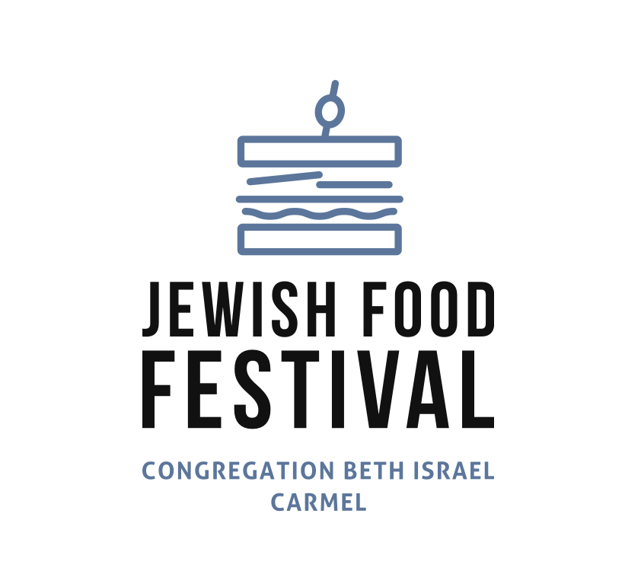 | 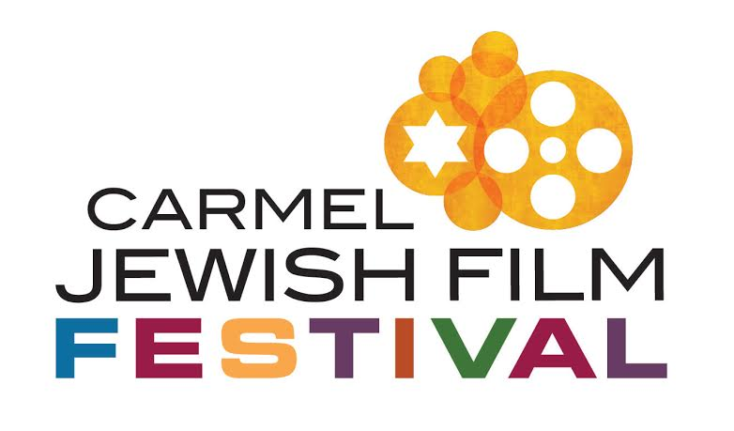
The Carmel Jewish Festivals bring our community together through two signature events.
Our Jewish Food Festival (July 26, 2026) is a lively outdoor celebration of Jewish cuisine, culture, and community. Our Jewish Film Festival features thoughtfully curated films presented over multiple dates in January 2027. Your sponsorship helps make these meaningful and engaging experiences possible.
JEWISH FOOD FESTIVAL JULY 26th, 2026  ☐ Season Supporter — $250  Name on Website + Program Recognition  ☐ Festival Friend — $500  Logo/Name on Website + Program + Shared Signage  ☐ Community Curator — $1,000  Enhanced Logo Placement + Main Signage + Custom Ad Announcement over PA 2x during Festival  ☐ Cultural Patron — $2,500  Named Booth Sponsor + Premium Logo  Placement on Website + Program | JEWISH FILM FESTIVAL JANUARY 2027  ☐ Season Supporter — $250  Name on Website + Screen + 2 tickets  ☐ Festival Friend — $500  Logo/Name on Screen + Program + 4 tickets  ☐ Community Curator — $1000  Sponsor a Film Screening + Name/Logo on Event Welcome Poster + Website + Screen + Program  + 6 tickets  ☐ Cultural Patron — $2,500  VIP Event Sponsor + Premium Logo on Event Welcome Poster + Website + Screen + Program + Festival Passes for 2 to all Films & VIP Events

COMBINED SPONSORSHIP
Business / Name: ________________________________
Contact: ______________________________________
Email: ________________________________________
Phone: ________________________________________
Send check to: Congregation Beth Israel, 5716 Carmel Valley Rd, Carmel, CA 93923 or call 831-624-2015 for credit card.

(BEST VALUE!)
☐ Season Supporter — $450
☐ Festival Friend — $900
☐ Community Curator — $1,800
☐ Cultural Patron — $4,500
☐ Other-Designate Your Sponsorship
_____________

